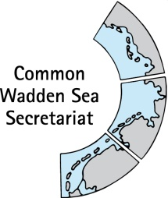
MEETING DOCUMENT
Ad hoc Working Group Swimway (WG-Swimway 21-1)
03 February 2021
Online meeting

Agenda Item: 7. Roadmap, Terms of Reference and future constituency
Subject: Roadmap 2020
Document No.: WG-Swimway 21-1/8/2
Date: 29 January 2021
Submitted by: all

This document contains a roadmap for WG- Swimway 2020 in the same version as tackled in document WG-Swimway 20-2/7/1.

Proposal: The group is invited to note the information.

Roadmap SWIMWAY 2020
V0.4, 2020-06-08

