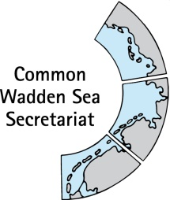
MEETING DOCUMENT
Expert Group Swimway (EG-Swimway 22-4)
10 November 2022
Online meeting

Agenda Item: 5 Trilateral Governmental Conference
Subject: Side event
Document No.: EG-Swimway 22-4/5
Date: 08 November 2022
Submitted by: Organisation committee TGC

From 28 November 2022 – 1 December 2022, the 14th Trilateral Governmental Conference (TGC) on the Protection of the Wadden Sea will be held in Wilhelmshaven, Germany. A draft overview of the programme is here https://www.waddensea-worldheritage.org/sites/default/files/220930_TGC14_Draft%20Programme.pdf

A side event of EG-Swimway in form of posters on the Swimway mid term review and interconnectivity with Smart Board was accepted by the organisors of the conference.
An organisation committee of Jeroen Huisman, Paddy Walker, Oliver Finch, Martha Buitenkamp, Andreas Dänhardt, chair and CWSS have developed a marching plan for products and process.
For organisation and moderation purposes, an almost final version of the messages/ presentations/ videos, etc is required by 11-14 November.

This document contains a draft plan for EG-Swimway contributions to the TGC.

Proposal: EG-Swimway is invited to agree with the products to be presented at the TGC to agree on (and add to) staffing of the Swimway stand

Wadden Sea Swimway at the TGC
Side events at the Trilateral Governmental Conference (TGC)
A number of topics will be presented as side events and workshops at the Trilateral Governmental Conference (TGC)from Monday 28 November until Wednesday 30 November 2022.

Amongst these is a presentation of Swimway Wadden Sea:

When: 28 Nov –1 Dec 2022
Where: Wilhelmshaven, Germany
Target: Inform general public/policymakers and ministers!
Ministers: walk around on Wednesday morning (see screenshot)
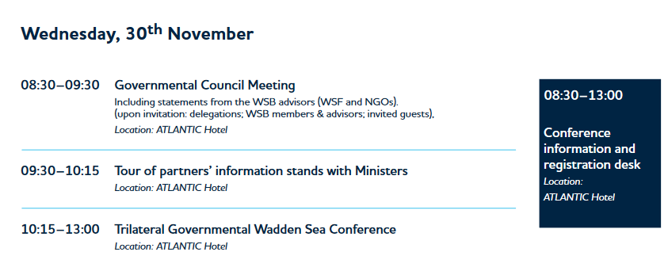

SWIMWAY side event
A permanent booth will be staffed by EG-Swimway over the entire time of the conference (see figure below).

Main message: (Sea Level Rise is there - ) Now is the time to act and ensure ecological connectivity in future plans (and this needs to be done in the beginning of planning). Between the lines: “our group works well and has obviously very good trilateral exchange, and show you here good examples of our products”

SETUP OF THE BOOTH IS PLANNED FOR MONDAY MORNING

It is planned to have:
- 1 poster Swimway Wadden Sea (Annex 1)
- 1 poster Mid term review (Annex 2)
- 1 Smart Board (GIS Board) interconnectivity: showing open passway and also barriers for fish passage in the Wadden Sea
- 1 flyer SHIRE (Annex 3)
- SWIMWAY Wadden Sea microsite to be presented on a laptop
- 1 minsters event (sluice doors, big red button, see below) on Wednesday 30 November 2022 (Annex 4)

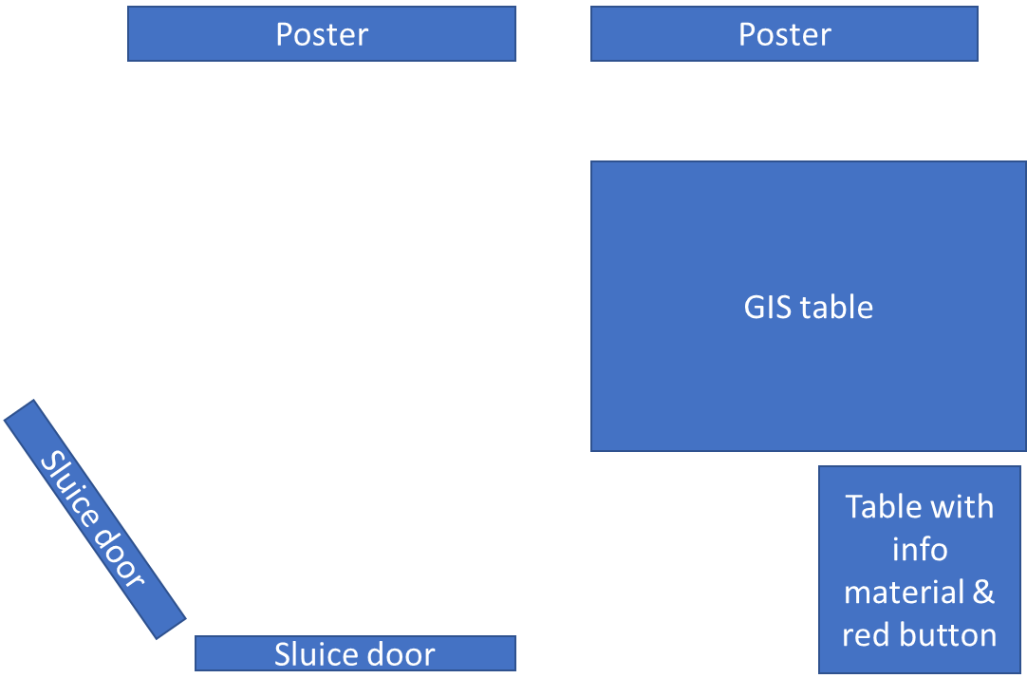 | Draft overview on booth.  Poster walls (back side) will be used as sluice doors on Wednesday
Products
Product | Main responsible | Execution | Costs
Flyer historical study (SHIRE) & SWIMWAY enamel pins | Paddy |  | Covered by SHIRE
Poster Swimway + vision signee logo’s (see Annex 1) | Julia, Oliver and Jeroen |  | Printing (10-20 EUR) CWSS
Poster mid-term review (see Annex 2) | Andreas, Adi |  | Printing (10-20 EUR) CWSS
GIS-Storyboard showing a map of the Wadden Sea, the WFD waterbodies and all the locations that have sluices, pumping stations, etc.  Message: (same as for ministers) please take action to incorporate connectivity in the plans. | Jeroen will bring GIS-table  Jeroen, Andreas, Oliver .  Status: maps are almost ready | Reserved, arrives on Sunday | €0
Big green button | Jeroen | Rental button  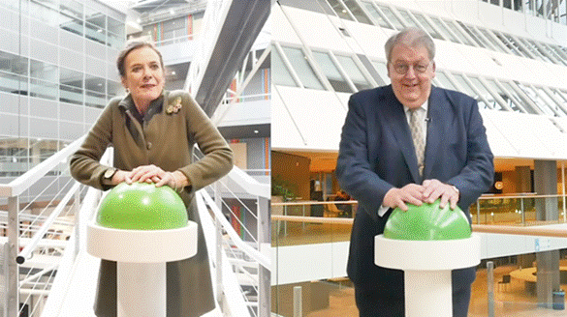 | +/- €178
Making Sluice doors – use poster with sluice doors on two poster walls | Julia will ask organisors |  | Printing oversize (+/- € 40)
Flag EG Swimway | Julia (existing) |  | €0
Laptop with Swimway Wadden Sea microsite | Who?
Swimway button | Paddy |  | Covered by SHIRE
Ministers event | Jeroen, all | Sluice door prints & stuffed fish | €350

Needed
Space approx. 6m² | Julia (asked organisors)
Electricity | Julia (asked organisors)
Table for info material (flyer) and red button | Julia (asked organisors)
Two poster walls | Julia (will ask organisors)
~15 Stuffed fish (Salmon, Sturgeon and …) | ordered
Laptop | Who? Jeroen, please bring spare to be sure!

Present at the side event
Who else will be present and willing to be present at the stand?
 | Mo (setup morning) | Tu | We
Jeroen | x | x | x
Martha |  | X | X
Oliver | X |  | X
Adi | X | X | (X) not 10:15 – 13:00
Andreas |  |  | X
Paddy |  | X | X
Niels (student) | ? | ? | ?
Julia: partially available

Overall needed budget, not including hours (estimate)
What | Costs | Who
GIS table | ~ | VHL
Big Green Button rental | € | CWSS
Stuffed fish (15 x €25) e.g., www.gabyfishpillows.com | €300 | CWSS
Posters Swimway printing | €30 | CWSS
Sluice doors, materials | €50 | CWSS?
Travel and lodging students | €500 | CWSS
Total | €880

ANNEX 1 Draft poster SWIMWAY and logos
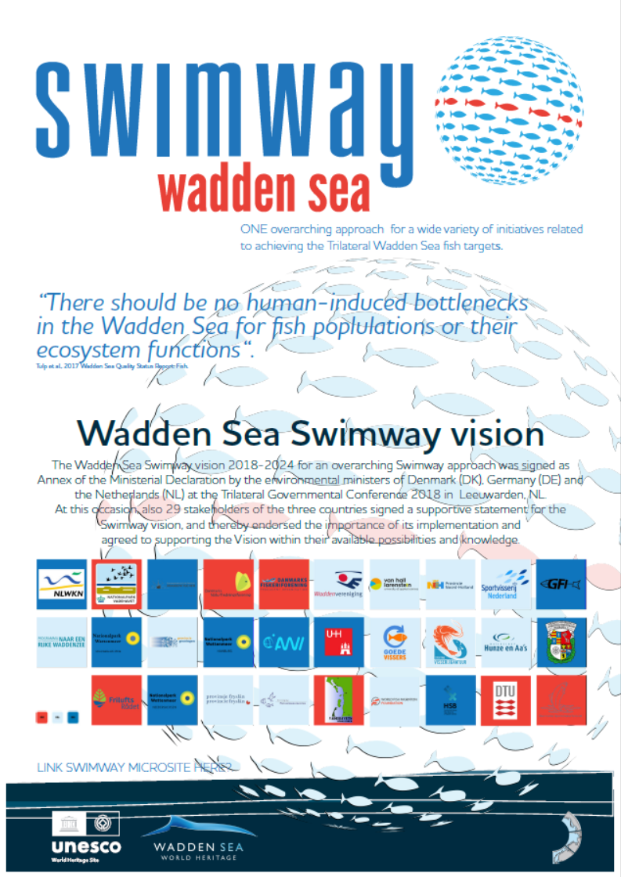

ANNEX 2 Draft poster (mid term review) EG-Swimway achievements
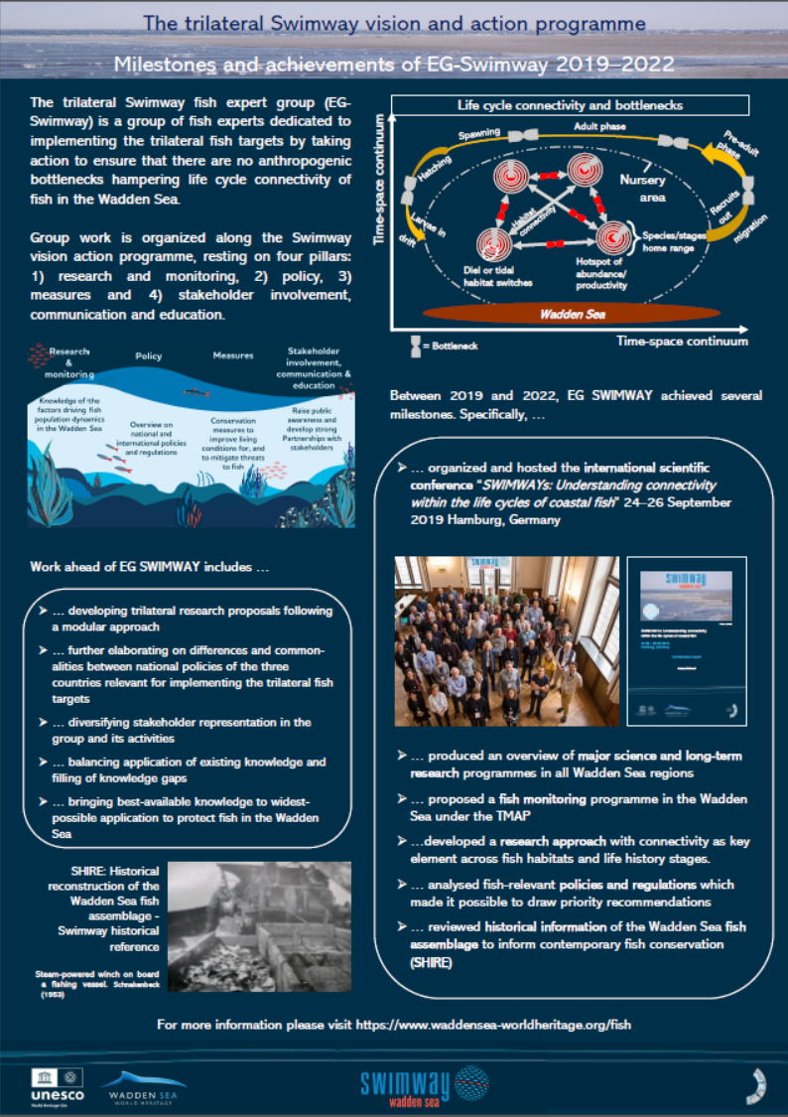
ANNEX 3 SHIRE flyer
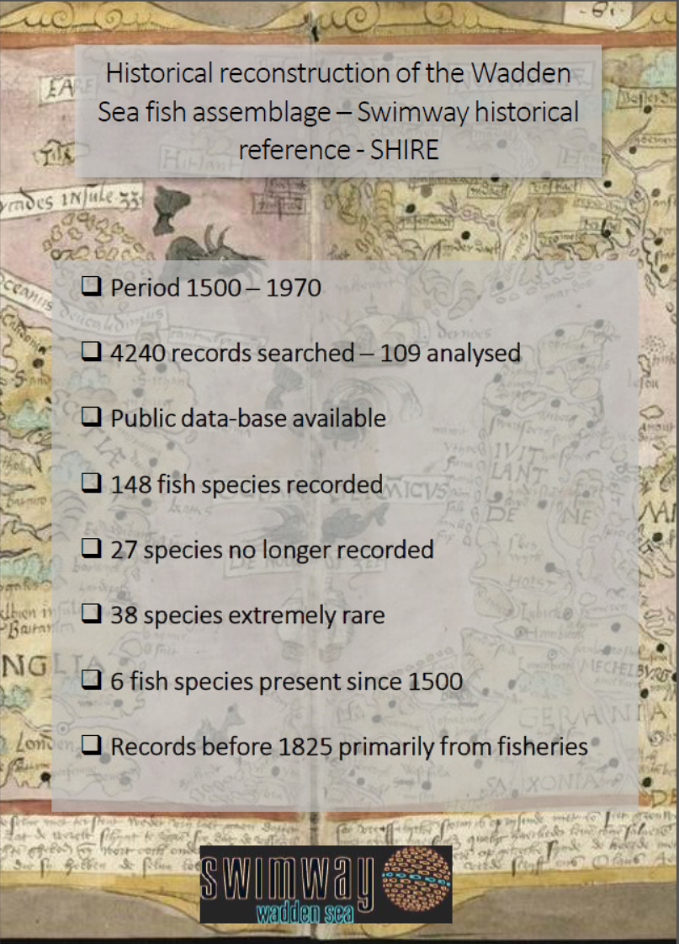
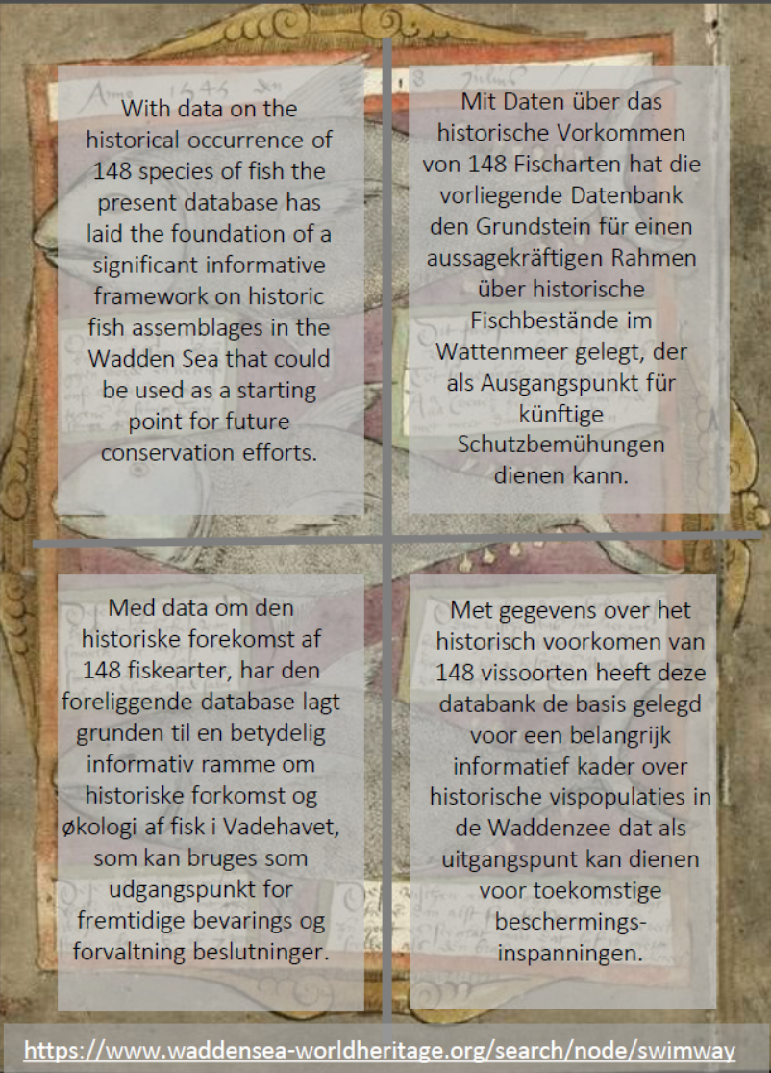

Additional: SHIRE bookmark
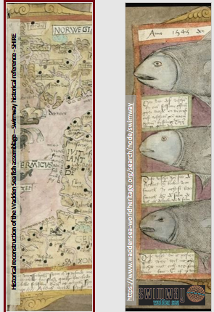
ANNEX 4 Minister´s tour
Time: Wednesday 30.11.22 – 9:30 – 10:15
Duration: ca 3 minutes
Core messages:
1) Fish and their ecological interactions with other species are integral for the function and structure of the Wadden Sea ecosystem.
2) Several fish species are in decline due to various known and unknown reasons.
3) Climate change- induced alterations of inland water management and sea level rise will pose increasing challenges to migratory fish
4) Various bottlenecks constricting life cycle connectivity of fish exist and need to be mitigated, among them physical barriers, anthropogenic mortality at different life stages and habitat destruction.
5) Until 2050, numerous sluices and pumping stations need to be refurbished, offering a window of opportunity to consider life-cycle connectivity for migratory fish.
6) The Trilateral Expert Group Swimway aims to develop measures to improve life cycle connectivity for fish, e. g. between tributaries and the Wadden Sea.

Format: By pressing a green button at the Swimway Wadden Sea booth, the three Ministers will symbolically show their commitment for continuing the implementation of the Swimway Vision and Action Programme (as depicted in the Ministerial Declaration Wilhelmshaven) and to continue using windows of opportunity for improving ecological connectivity/ fish migratory routes (e.g., when existing structures, such as sluices are renovated).
Upon pressing the red button by the ministers, two poster walls with poster of sluice door will open and allow student(s) with stuffed pet-fish to pass. The ministers will be handed one of the pet-fish each.

Who will present and explain:
Jeroen Huisman (Van Hall Larenstein University, Netherlands) will welcome the Ministers and introduce the topic:
- Fish and their ecological interactions with other species are integral for the function and structure of the Wadden Sea ecosystem.
- Many fish species, amongst them red list species, in the Wadden Sea are declining– due to various known and unknown reasons.
- We need to do more for implementation of the Trilateral Fish Targets and thereby for a healthy fish population.
- Climate change- induced alterations of inland water management and sea level rise will pose increasing challenges to migratory fish
- Various bottlenecks constricting life cycle connectivity of fish exist and need to be mitigated, among them physical barriers, anthropogenic mortality at different life stages and habitat destruction.
- Until 2050, numerous sluices and pumping stations need to be refurbished, offering a window of opportunity to consider life-cycle connectivity for migratory fish.
- The Trilateral Expert Group Swimway aims to develop measures to improve life cycle connectivity for fish, e. g. between tributaries and the Wadden Sea.
- With the trilateral SWIMWAY Wadden Sea and the the Swimway Vision and Action Programme we made a start – but still there are a number of barriers for fish that hinder free passage to their breeding grounds/completion of life cycle
- With pushing the red button we welcome the Ministers to symbolically open these sluice doors for ecological connectivity in the ONE Wadden Sea– symbolizing their commitment for the Swimway Vision and Action Programme and in the next four years to use windows of opportunity when existing structures are renovated to open migratory routes for fish.. and to encourage EG-Swiwmay to continue their work to improve life cycle connectivity for fish, e. g. between tributaries and the Wadden Sea.

