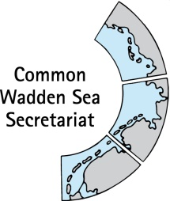
DRAFT AGENDA v0.2
Expert group Climate Change Adaptation
(EG-C 12)
9 February 2022
Online meeting

- Opening of the Meeting and adoption of the Agenda
The meeting will be opened by the Chairperson at 09:30 on 9 February 2022.
Proposal: Adopt the draft agenda of the meeting

- Adoption of the draft summary record
Document: EG-C12-2-SR-EG-C11
Proposal: Adopt the draft Summary Record of EG-C 11.

- Announcements
Document: EG-C12-3-Announcements
Meeting participants are invited to hand in their information to the CWSS before the meeting. Individual announcements will not be repeated, but time given for questions [all].
Proposal: Note the information

- Work plan 2022 - 2026
Plan activities for 2022, the next presidency until 2026.
Proposal: Plan and agree on activities

- Trilateral Governmental Conference (TGC)
Document: EG-C 12-5 call for side event
Discuss EG-C side event at the TGC., storybook presentation by Claus von Hoerschelmann.
Proposal: Agree on side event(s) (and suggest to German presidency)

- Climate Vulnerability Index (CVI)
Document: EG-C 12-6 CVI 2 report
Information on progress with the CVI 2 workshop report.
Proposal: Note the information

- Any Other Business and next meeting
Any other business
EG-C 13 Tuesday 26 April 2022 (online)
Proposal: Note the information

- Closing
The meeting will be closed no later than 12:00 on 9 February 2022.

